Assessment - 2

1. Git Setup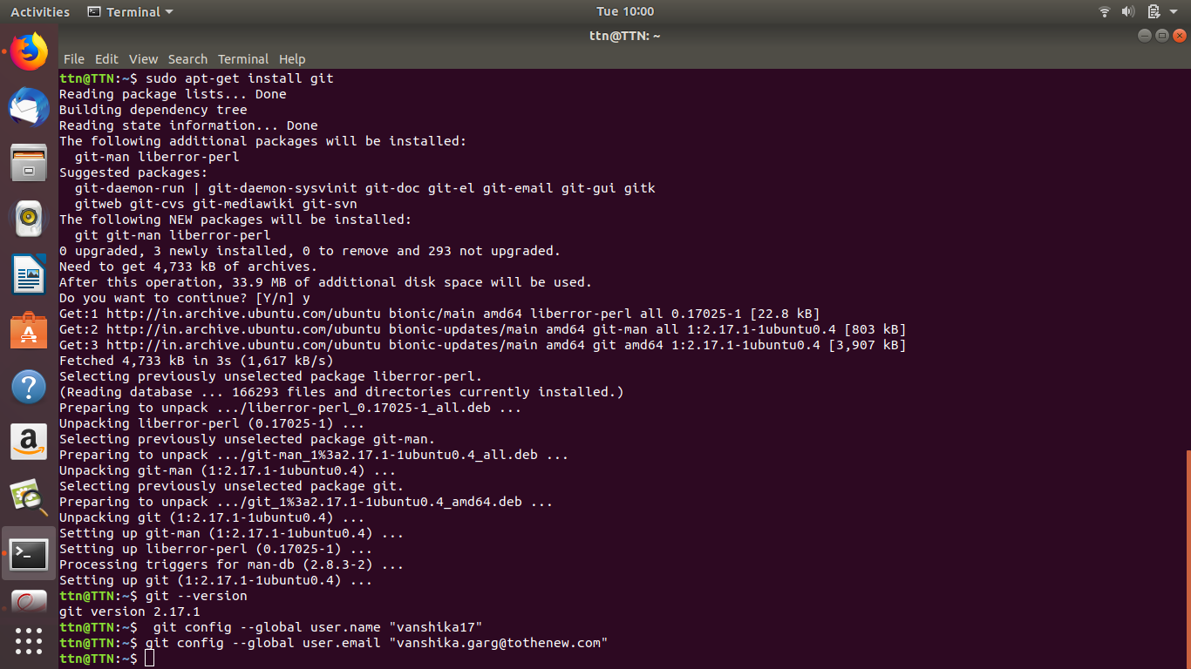
2. Initialize a Git Repository
3. Add files to the repository
4. Unstage 1 file

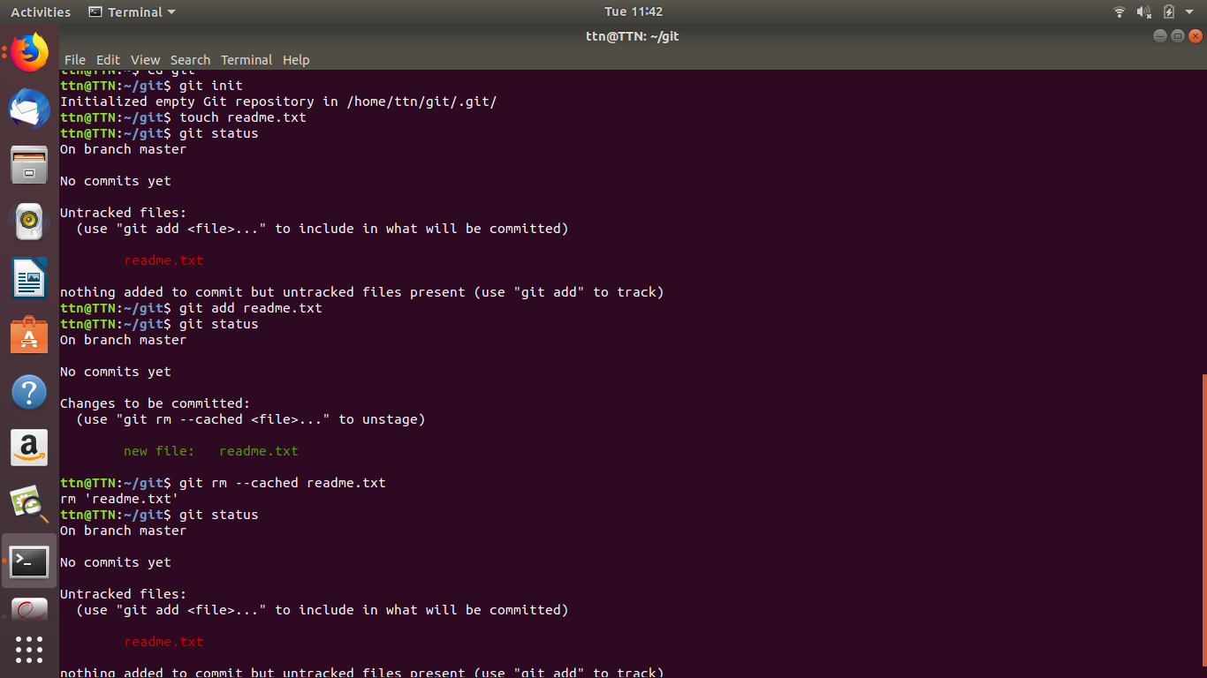

5.Commit a file

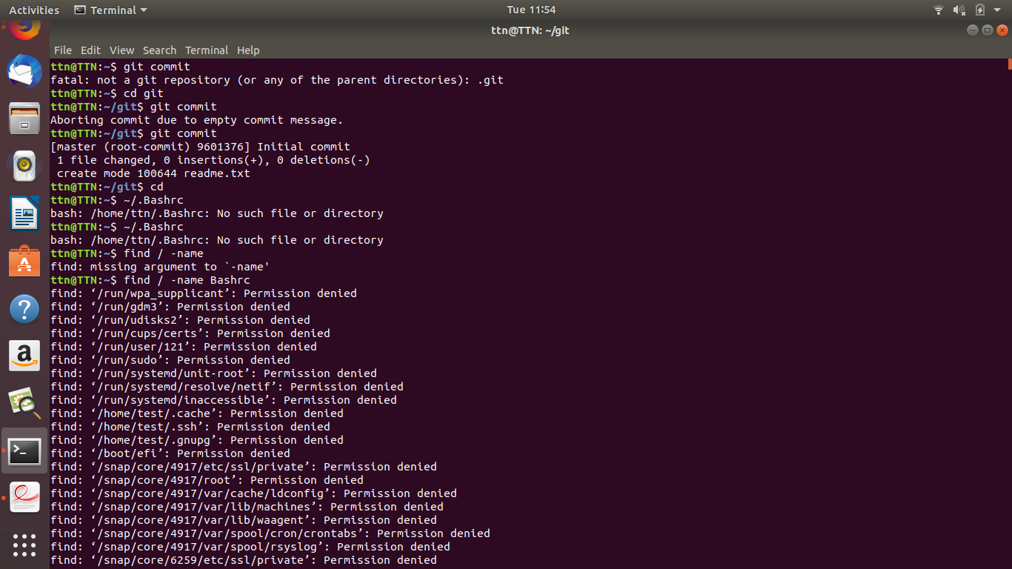

6.Ad a remote

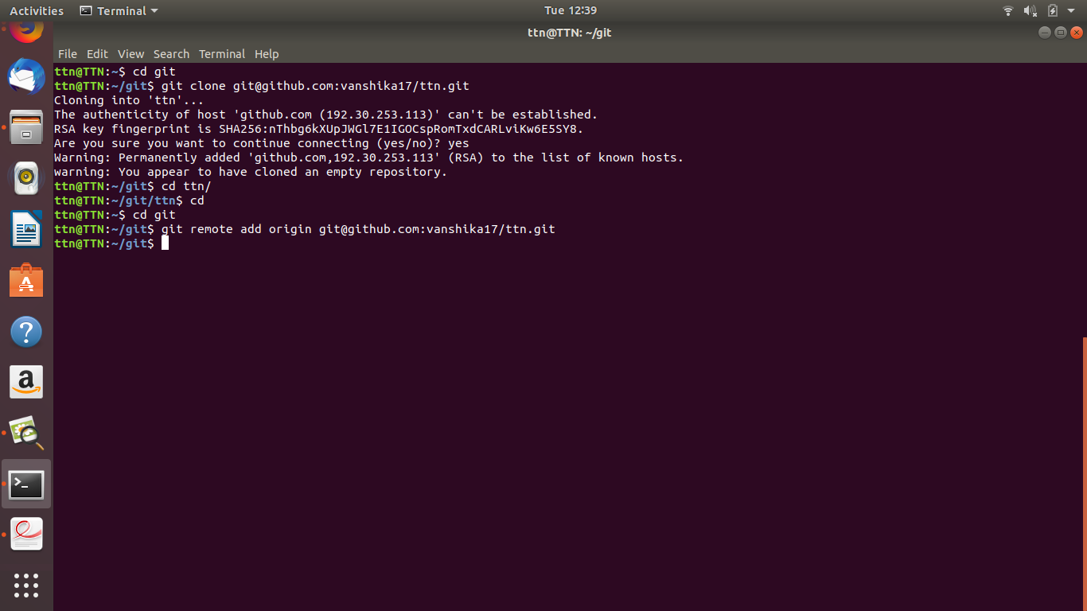

7.Undo changes to a file

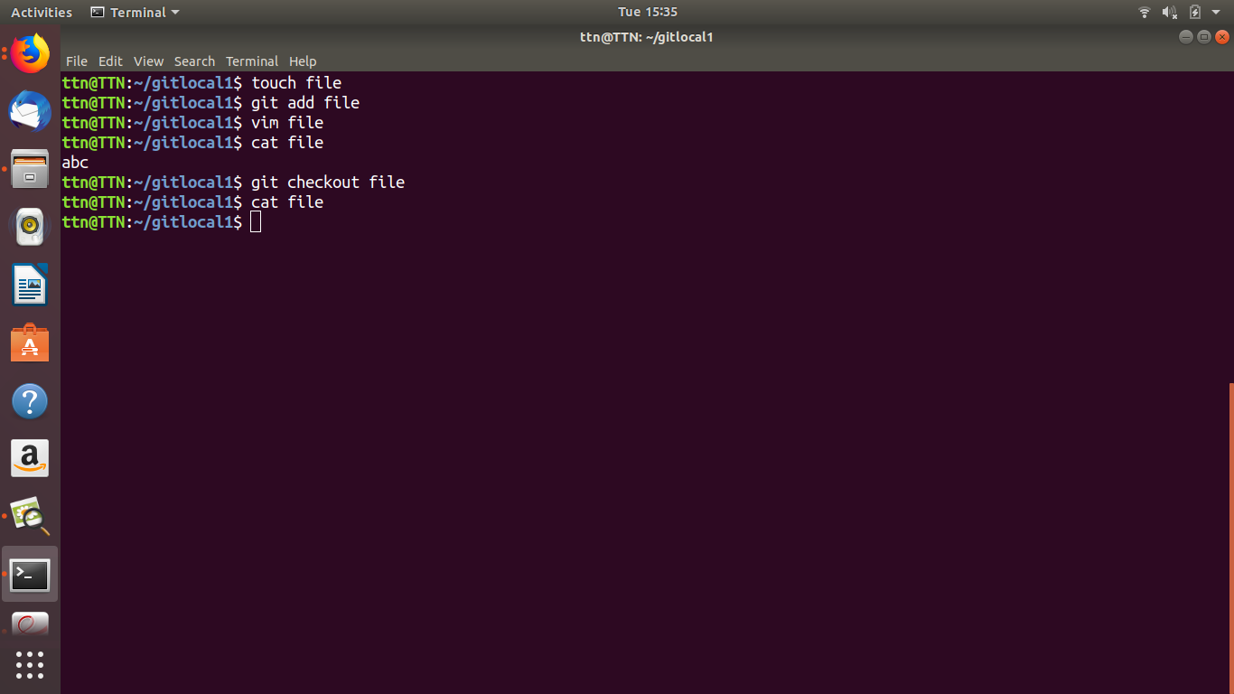

8.Push changes to Github

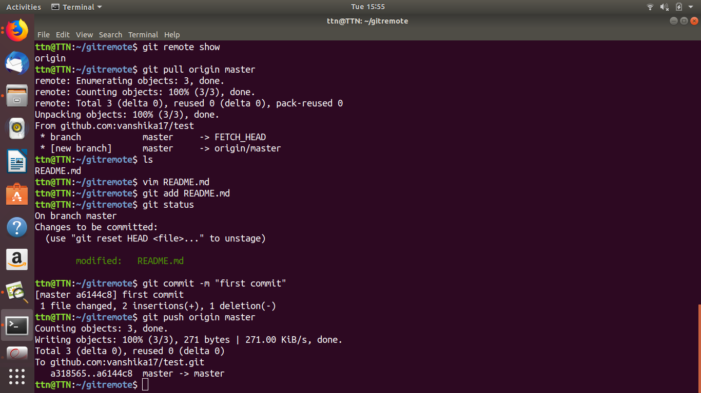

9. Clone the repository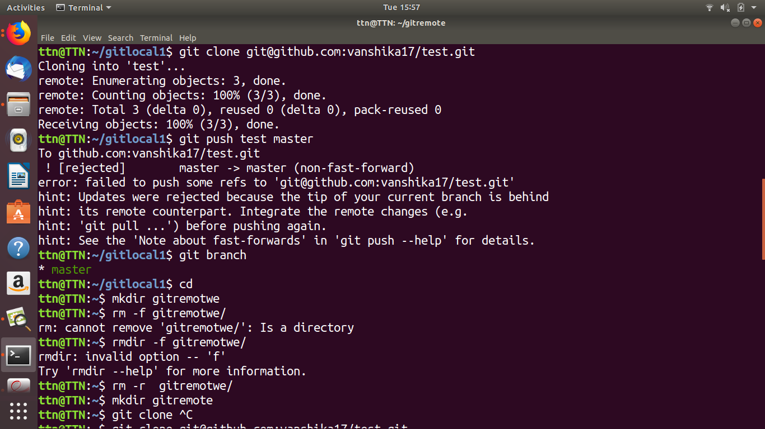

10.Add changes to one of the copies and pull the changes in the other.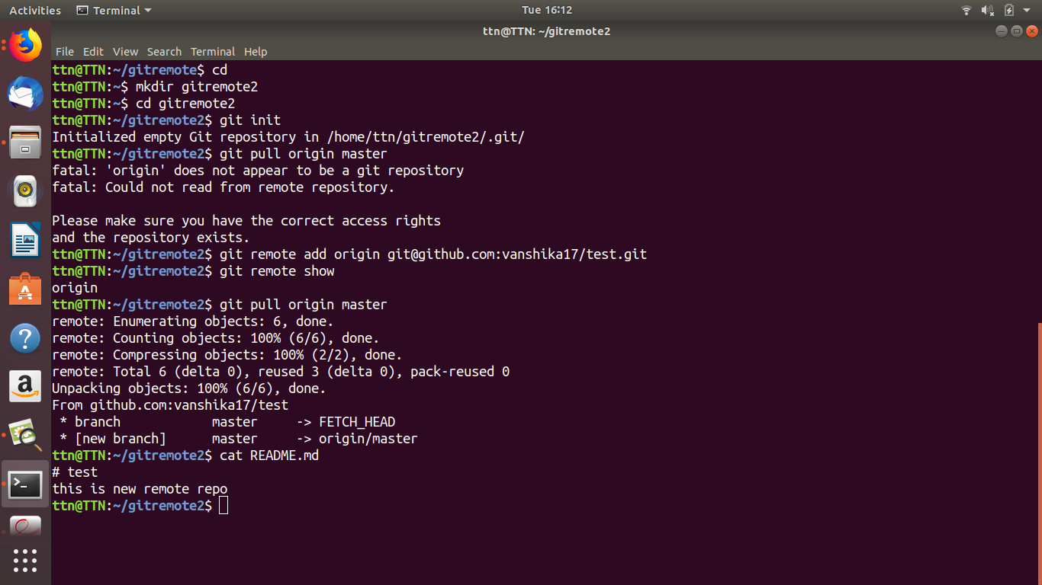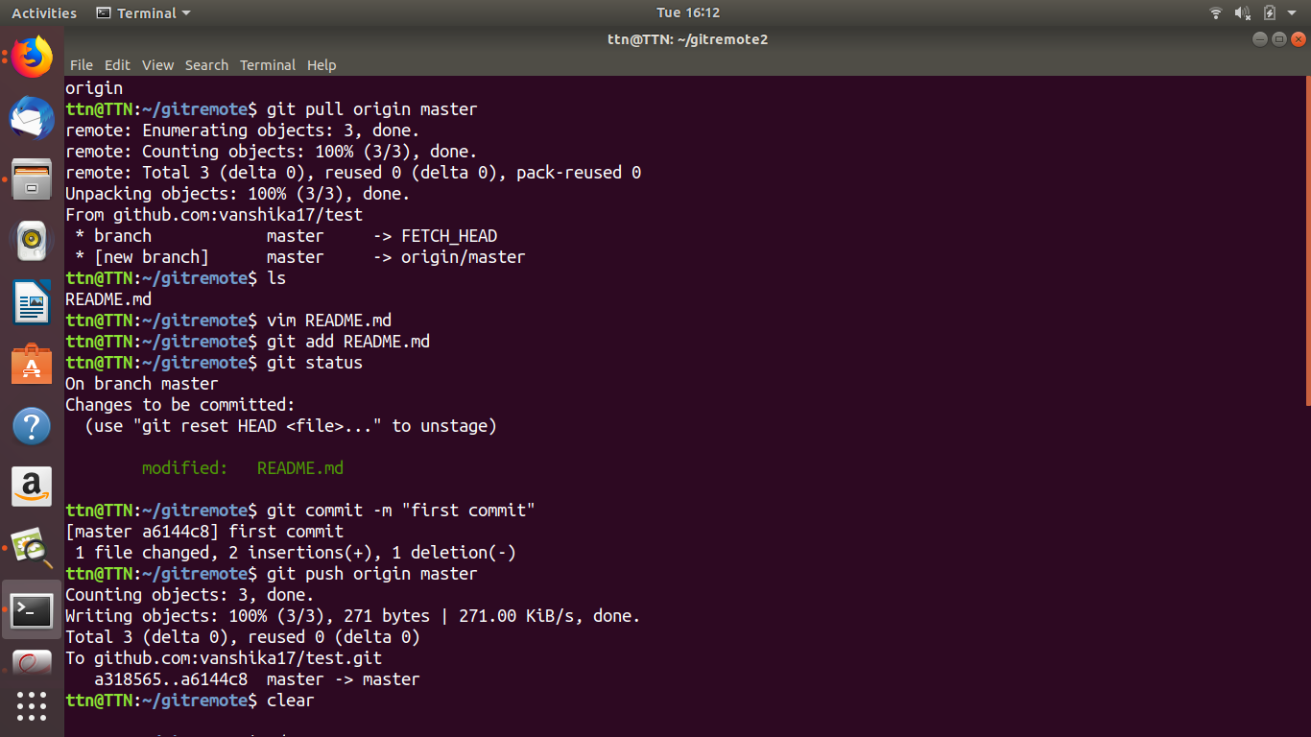

11. Check differences between a file and its staged version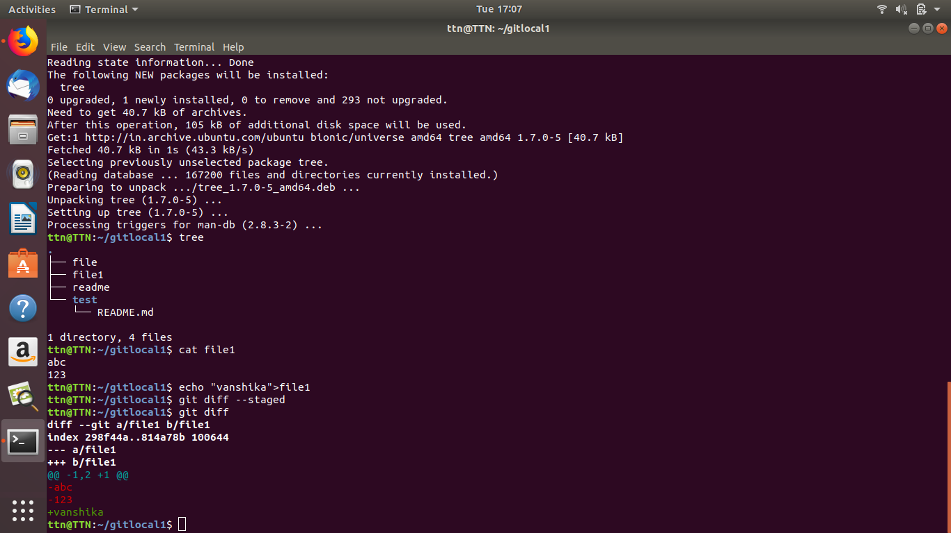

12. Ignore a few files to be checked in

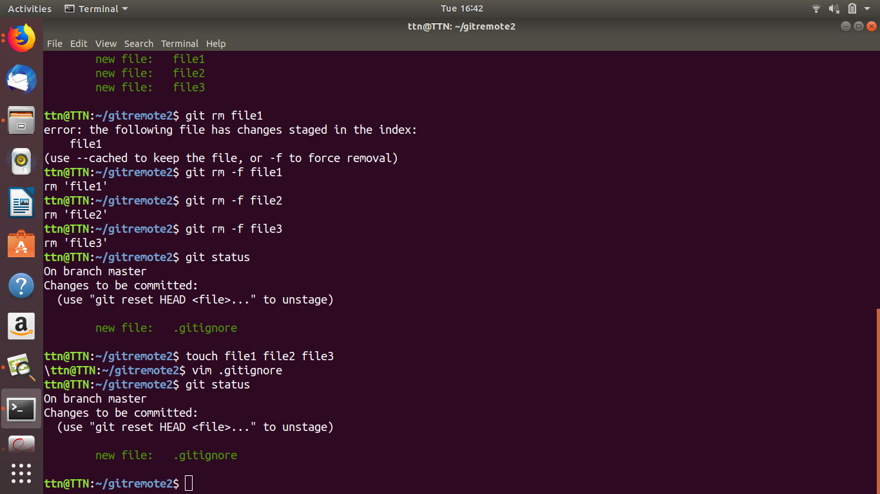

13. Create a new branch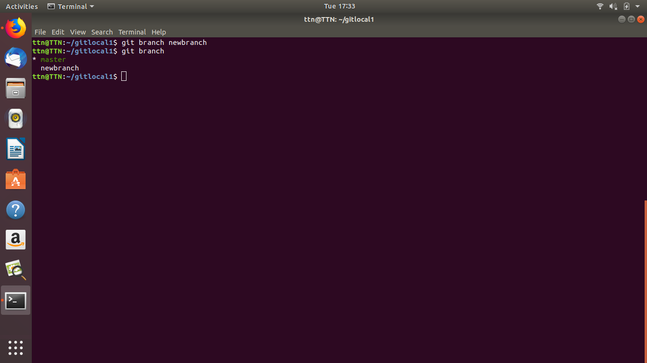

14. Diverge them with commits 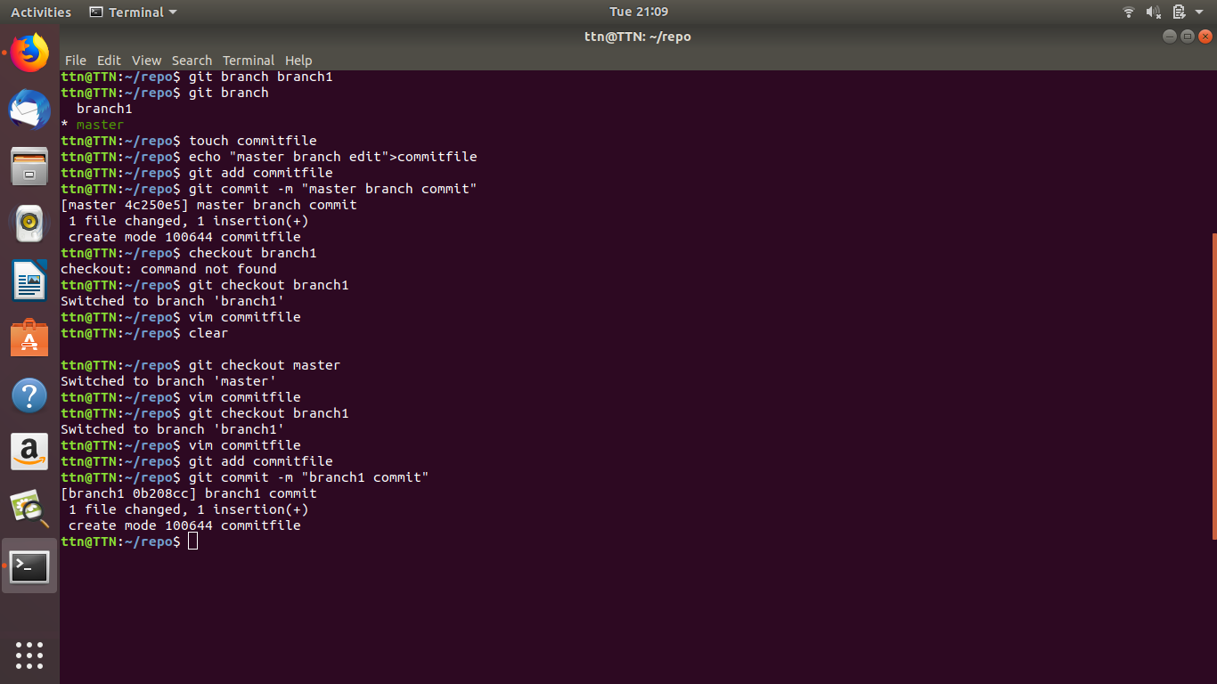

15. Edit the same file at the same line on both branches and commit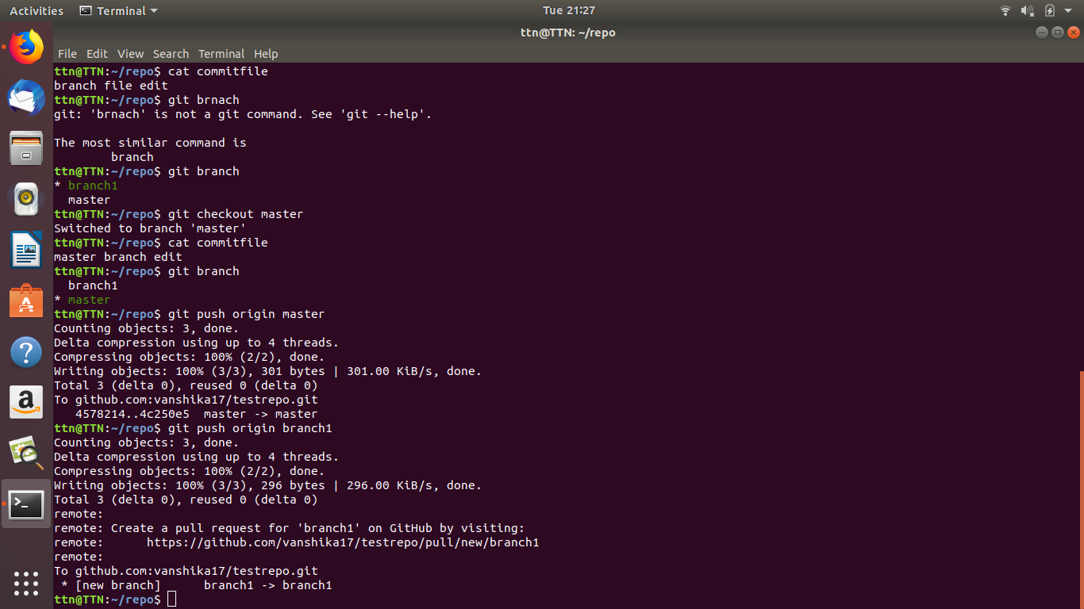

16.Try merging and resolve merge conflicts 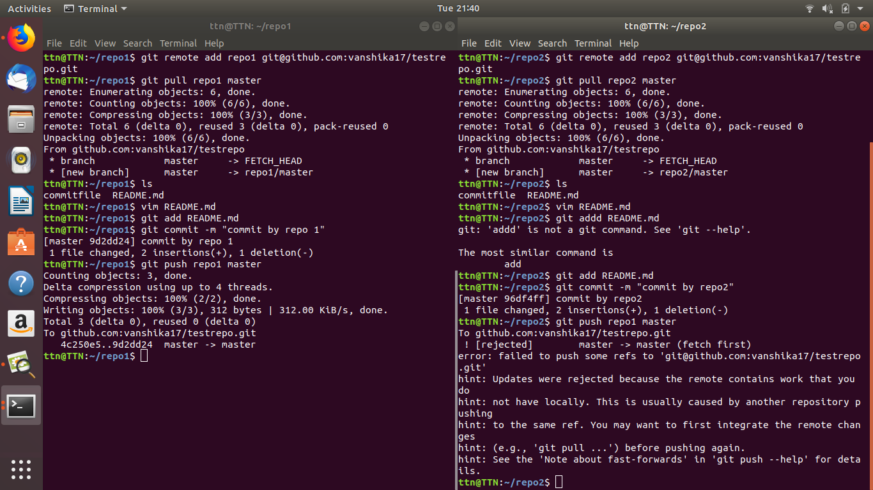

17. Stash the changes and pop them

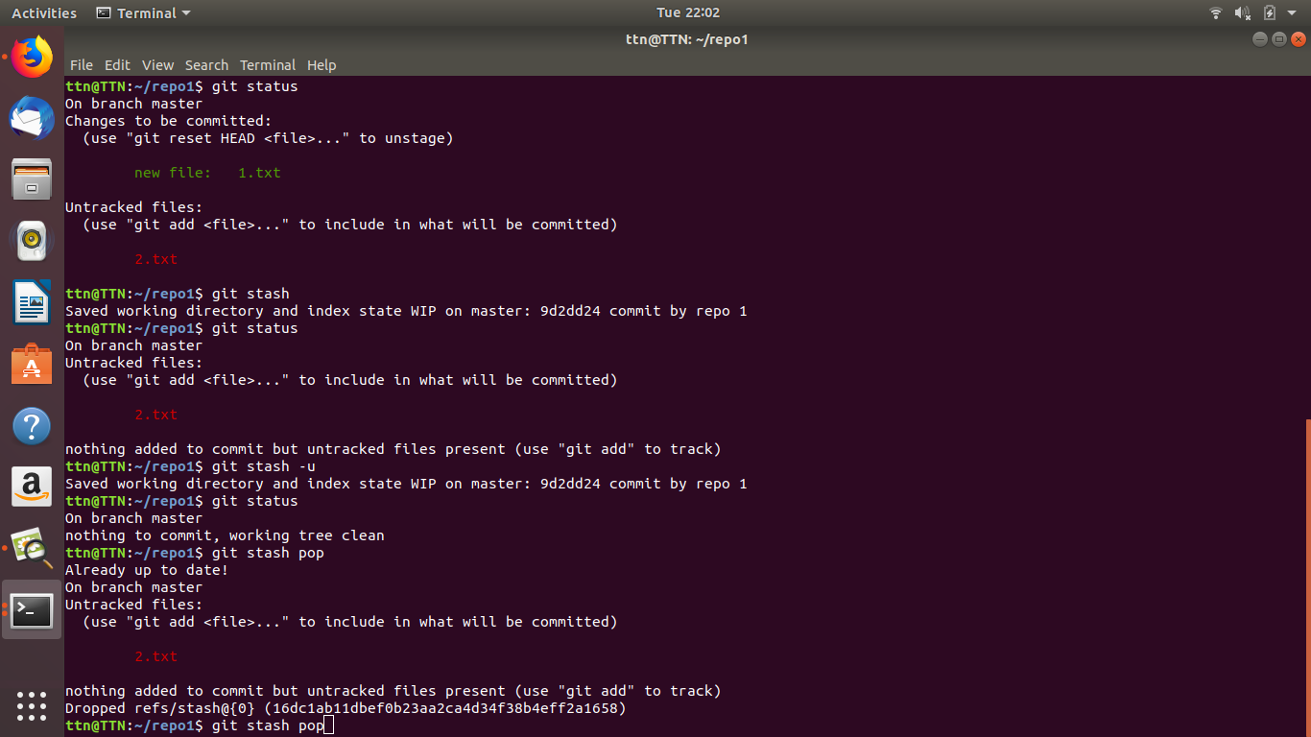

18.Add the following code to your .bashrc file : color_prompt="yes"

parse_git_branch() {

git branch 2> /dev/null | sed -e '/^[^*]/d' -e 's/* \(.*\)/(\1)/'

}

if [ "$color_prompt" = yes ]; then

PS1='\u@\h\[\033[00m\]:\[\033[01;34m\]\W\[\033[01;31m\] $(parse_git_branch)\[\033[00m\]\$ '

else

PS1='\u@\h:\W $(parse_git_branch)\$ '

fi

unset color_prompt force_color_prompt

